APPLICATION ENGINEERING & DEVELOPMENT ​

**ASSIGNMENT NUMBER 3**

​(Fall 2021)

**UNIVERSITY RANKING SYSTEM**

Submitted by:

1. Prachi Kunjir [kunjir.p@northeastern.edu](mailto:kunjir.p@northeastern.edu) 002197614
2. Pradnya Chacharkar [chacharkar.p@northeastern.edu](mailto:chacharkar.p@northeastern.edu) 002194825
3. Sagar Jalindar Khandagale [khandagale.s@northeastern.edu](mailto:khandagale.s@northeastern.edu) 002197761

**Model Purpose**

* The main purpose of this application is for the University admins to monitor the University’s
* Performance based on various factors. The role of this model is to take into consideration
* Student performance, faculty performance, alumni performance and other factors to maintain a score for each entity.
* With the help of LinkedIn data, we can keep a track of details of our alumni. Overall, we will maintain a score for each of the required entities. Based on this, a rank will be assigned which will be displayed to the University Admins.

**Business Problems Addressed**

1. Only College and University Administrators are given the access in order to view Performance metric of their academic units.
2. Admins, Employee and Users can login to the application using their respective Login credentials.
3. The application measures the performance of a college that are based on the rankings those are acquired by the department, courses, faculty and students.
4. Various Student details such as name of the student, age, contact details, email address, department name and college name is stored for every student.
5. University holds the access to all the college details  and they also have the authority to  add and modify the details.
6. College details such as college Id, college name, various departments and college ranking is stored in the college class.
7. Faculty class possesses details of the faculty working in the college. It includes details such as name, age, email, contact, qualification, designation. It also includes the courses taught and the rank assigned by the faculty.
8. Alumni class stores the details of the graduated students. It contains the details of their name, address, year of graduation along with their employment details.
9. Each department has a set of courses and concentration to choose a favorable career track. It includes course details like course Id, name, credits assigned and course rankings are stored in the course class.

University:

1. We have created the university class as a master class.
2. University is then connected to department and various colleges which are having different colleges.
3. University class consist of university details such as name, address, etc.

College:

1. College is a subpart of the university where one university had many colleges under it.
2. University and college has one to many relationship
3. College has college details like name, dean and location. It has getElibility method where we will check if the applicant is eligible for college.

Department:

1. Department has department details and faculty information.
2. Department performs 2 of the following methods: 1. Assigning the faculty to the course and 2. Managing, i.e deciding the fees/funds of courses.

Course Catalogue:

1. Course catalogue has number of courses, course id and its description.
2. It has a method where this class categorizes the courses so that it can be grouped into one concentration.

Course Concentration:

1. It has advisorHelp function where it can smartly recommend the suitable course concentration.
2. It takes string variables for concentration pathways, concentration details and total concentrations.

Courses:

1. This is very important class since it has the course id, course name, credit hours and credit cost.
2. It has methods which gives you career outcomes of the course chosen.
3. It also gives you course ranking.
4. It is a superclass of thesis and Non thesis class.

Thesis:

1. It gives all the information of the thesis courses and has parameters like thesis guidelines.
2. You can do register to the thesis course using register method.

Non Thesis.

1. It has the same methods inherited from the thesis class but parameters are different.

Course Offering:

1. It gives further details of the courses like number of seats available, waitlist numbers, ets.
2. It has method called totalOccupancy which will show you availability.
3. This class will also get the courses which are available.

Department Student Directory:

1. It is the mail directory class which has which is the inherited by student class.
2. This class has variables set to get student data like, name, contact, address, etc.
3. This class also has student compliance information and current status of the student.

Student:

1. This has student details like the courses taken, start date, etc.
2. This class has getStudentDetails() method.

Undergraduate:

1. If the student is undergraduate, then all the relevant academic records will be collected.
2. This class has getAcadRecords() method.

Graduate:

1. If the student is graduate, then all the relevant academic records will be collected.
2. This class has getAcadRecords() method.

PHD:

1. If the student is phd, then all the relevant academic records will be collected.
2. This class has getAcadRecords() method.

Academic Interest:

1. This class is connected to the student class, and contains the student’s career interest.
2. It has students previous experience, preferred concentration and advising and support variables.
3. This class has getAdviserInfo() class.

Career Path Guidance:

1. This class is connected to the academic interest class, and contains the assigned advisor career interest.
2. It has logic written to provide course track and give the access to internship portal.

University internship portal:

1. This portal class will help students to apply for internship opportunities.
2. It gets job id, job description, application eligibility variables. Application eligibility is to check if the particular job is just for undergraduates, the those eligible can only apply.
3. It has logic written for searching and applying for a internship.

Person:

1. This is very initial class which will allow us to identify whether it’s an alumni, student or employee of the university.
2. It gets a person’s information like name, contact and information.
3. It has getPersonInfo method.

Student/Alumni/Employee:

1. These classes have getDetails class according to class and category.
2. Depending on whether it’s a student or employee or employee variables are taken for their information.

Registrar:

1. This class has been taken to manage the student directory hence it has
2. It has registrar’s information like id and office name.

Academic Advisor:

1. Academic advisor is used to analyse students and then to give career guidance.
2. It has variables: advisor id and department.

Faculty:

1. Faculty is of various curses. One faculty can have many courses and we are providing faculty ranking as well for students to decide which faculty to choose.

Academic History:

1. We have taken alumni’s academic record to track the career growth in concentration chosen. It will help new students to understand industry trends.

Career Growth:

1. To find out alumni’s career growth, we have considered job role, salary, promotion.
2. We have made a function to calculate employee’s performance and to get details.
3. Performance calculation will be decided by variables considered.

Alumni Networking:

1. This class is given for students to connect with alumni to discuss courses, faculty and for guidance.
2. We have taken alumni’s linkedin info and whether if an alumni is active or not.
3. It has getAlumniDetails(), getGuidance(), contactalumni(), etc functions.

Ranking:

1. By checking an alumni’s performance, we are giving that course a ranking. Many alumni’s data will be considered for this.
2. It takes course and faculty ranking into consideration as well.
3. It has alumniPerformance(), coursesTaken(), evaluateFeedback(), evaluateSurvey(), etc.

Feedback:

1. Feedback is taken from an alumni and from student and it has feedback id variable to analyse each survey. It is anonymous so we have considered to give feedback an id.
2. It has studentFeedback() and alumniFeedback() methods.

Survey:

1. Survey is taken from an alumni and from student and it has survey id variable to analyse each survey. It is anonymous so we have considered to give feedback an id.
2. It has studentSurvey() and alumniSurvey() methods.

Diagram 1: Class Diagram

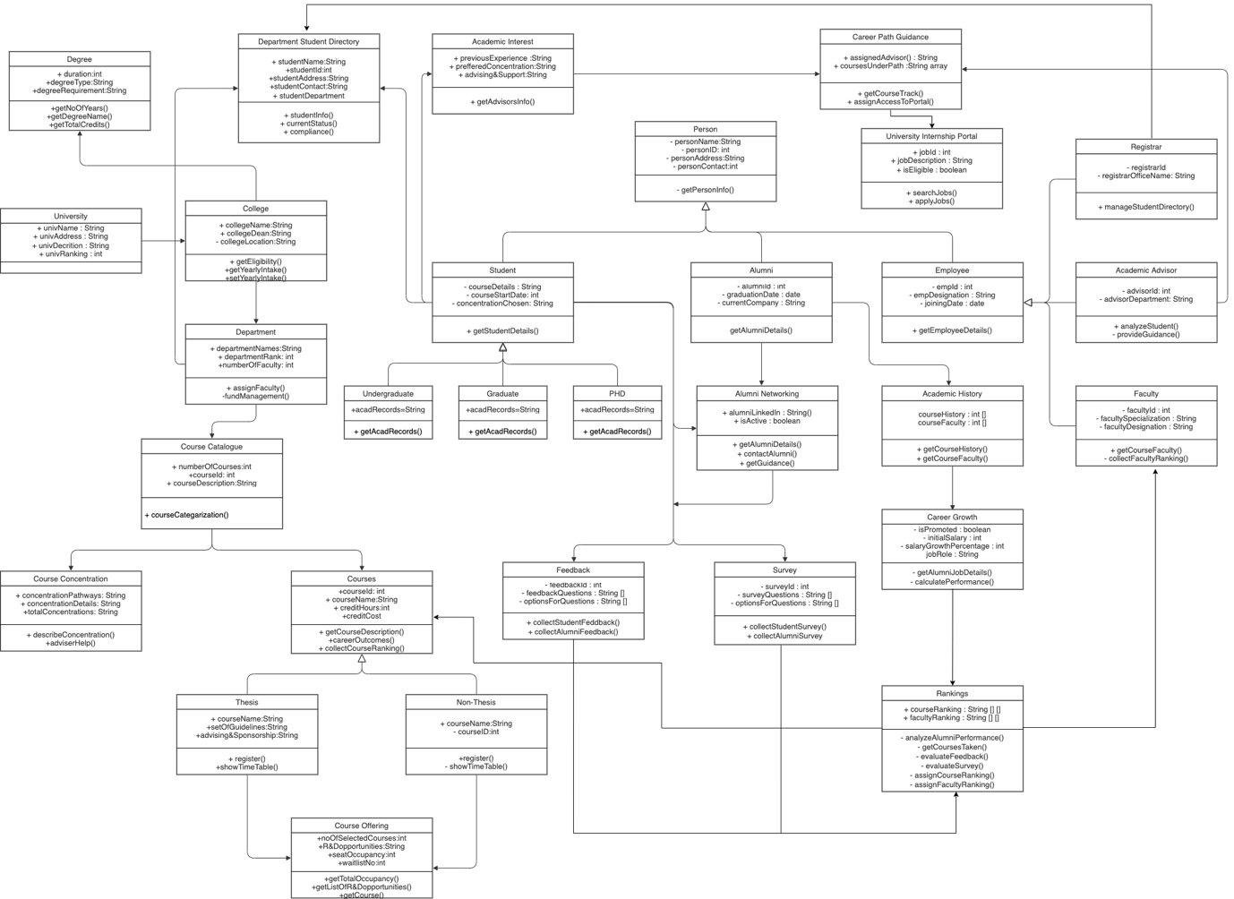

Diagram 2: Feedback Sequence Diagram

Diagram 2: Survey Sequence Diagram

**USER LOGIN:**

**STUDENT DIRECTORY MANAGEMENT:**

**ALUMNI ENTRY:**

**COURSE DETAILS:**

**ALUMNI SEARCH:**

**FEEDBACK FORM:**

**DASHBOARD:**

